Drawing Shapes on Tinkercad
Project 1
Problem Statement: Create a “3D rectangular block” in the Tinkercad workspace,
ensuring it follows the specified dimensions and attributes.
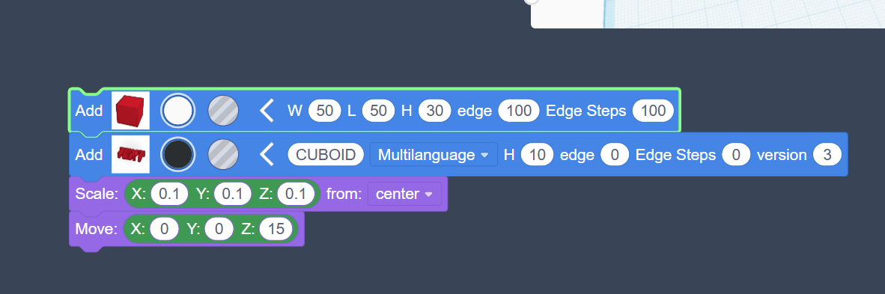

Project 2
Problem Statement: Create an hourglass, in the Tinkercad workspace, ensuring it
follows the specified dimensions.

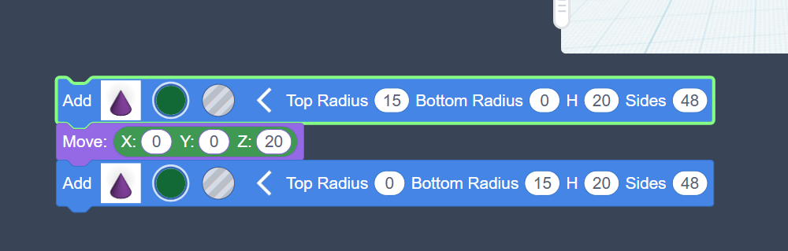
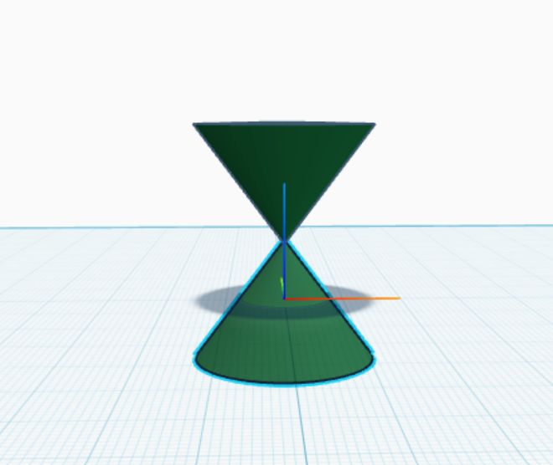
Dimensions and Rotate Feature in Tinkercad

ist all the objects that you can find around you or Look at the image and identify all possible shapes.
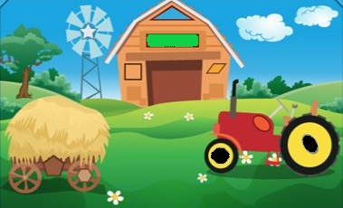

We experience the world in three dimensions. Just like the book you are holding or the chair you are sitting on. Everything around you are mostly three dimensional.
This is just a normal thing for any of us. But have you ever thought about what these dimensions are and how do they shape the world?
Dimension is a special way of measuring how big or far things are. It helps us to understand how much space something takes up. There are multiple types of dimensions available, however, for our learning we will focus on 2D and 3D dimensions.
- 2D : A two-dimensional (2D) object is an object that only has two dimensions, such as length and width, and no thickness or height.
For example, the square drawn on the paper is a 2D object.
- 3D : A three-dimensional (3D) object is an object that has three dimensions such as length, width, and height.
For example: ball, bench, textbook, computer etc.,
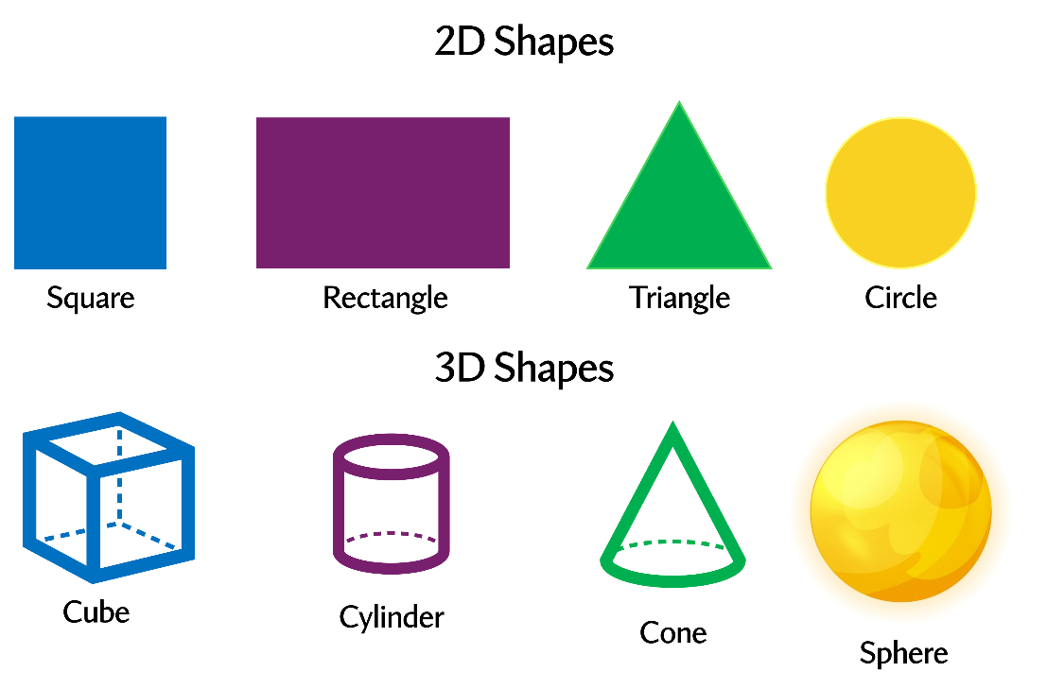

Now that we are quite familiar with dimensions and let us focus on different features of Tinkercad. Let us explore one newer feature of Tinkercad the Rotate.
Let’s start with a small activity “Rotate the Arrow”
Draw an Arrow on a piece of paper and rotate the paper, observe the change in direction of the arrow.
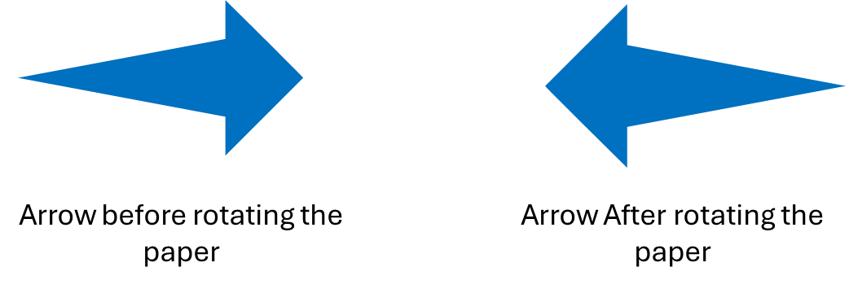
Looks very simple right? But how do you rotate shapes created on a digital platform like Tinkercad?
That’s when the Rotate function/option comes into rescue. Yes, the rotate option allows you to turn objects around a specific axis.
Here is how it looks,

One simply needs to drag and drop the rotate block and attach it just below the object that you want to rotate. Then, specify the axis along which the rotation should occur.
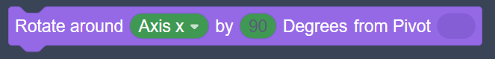

Rotating objects in Tinkercad seems simple, right? That’s because Tinkercad is designed to be user-friendly. It also has many powerful features hidden within, allowing you to create incredible designs with ease. Let's explore two more blocks, Render and Roof block.
Render: Rendering is a step-by-step execution of how each code block would work! At the top section of Tinkercad platform, you’ll notice a list of button, which includes options like speed control, a run button, and a step button. When you click the run button, the output is displayed step by step for you and this process is known as rendering.
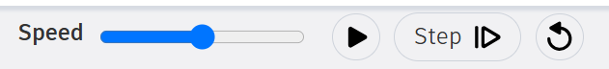
Roof Block: Just like a roof on a house, the Roof block in Tinkercad has a triangle shape on top and a flat base. It’s used to build things like rooftops, ramps, tents, and even rocket tops..
